Medical Care Collections Fund (MCCF) eBilling

Electronic Data Interchange (EDI)

Transactions Applications Suite (TAS)

Interface Control Document

For the interface between MCCF EDI TAS and

The Financial Service Center (FSC)

ASC X12N/005010 278-217 Health Care Services Review

– Request for Review and Response

ASC X12N/005010 278-215 Health Care Services Review

– Inquiry and Response

Logo for the Department of Veterans Affairs, Office of Information and Technology, Product Development, including the official seal of the Department of Veterans Affairs


Department of Veterans Affairs

May 2018

Version 3.4

Revision History

|  |  |  |  |
| --- | --- | --- | --- |
| Date | Version | Description | Author |
| 2/20/18 | 0.0.1 | Initial creation of document | Steffen Maerdian - Halfaker |
| 2/28/18 | 0.9 | Finalization of draft | Steffen Maerdian - Halfaker |
| 3/5/18 | 1.0 | Draft review and update | Keith Oulson – Halfaker & Associates |
| 3/19/18 | 1.1 | Incorporating review remarks from FSC and product team | Steffen Maerdian - Halfaker |
| 3/22/18 | 1.2 | Finishing missing sections | Steffen Maerdian - Halfaker |
| 3/26/18 | 2.0 | Final Draft Review | Keith Oulson – Halfaker & Associates |
| 04/06/2018 | 2.5 | Review | EDI BA’s |
| 04/10/2018 | 3.0 | Review | Sarah Snyder, Project Manager - GCIO |
| 4/13/2018 | 3.1 | Incorporating FSC review comments | Keith Oulson – Halfaker & Assoc. |
| 4/18/2018 | 3.2 | Adding elaborated testing sections from ICD call | Steffen Maerdian - Halfaker |
| 4/19/2018 | 3.3 | Adding latest mapping sheet | Steffen Maerdian - Halfaker |
| 04/25/2018 | 3.31 | Corrected signature page according to Frank Annecchini | Keith Oulson – Halfaker & Associates |
| 5/11/2018 | 3.4 | Adding corrected JSON files | Steffen Maerdian - Halfaker |
|  |  |  |  |
|  |  |  |  |
|  |  |  |  |
|  |  |  |  |
|  |  |  |  |
|  |  |  |  |
|  |  |  |  |

Table of Contents

1 Introduction 1

1.1 Purpose 1

1.2 Scope 1

1.3 System Identification 1

1.3.1 MCCF EDI TAS eBilling 1

1.3.2 FSC 2

1.4 Operational Agreement 2

2 Interface Definition 3

2.1 System Overview 3

2.1.1 Overview Diagram 4

2.2 Interface Overview 6

2.2.1 Connectivity between the systems 6

2.3 Operations 6

2.3.1 Data Extraction 7

2.3.2 Data Transformation 7

2.3.3 Sending/Receiving 7

2.4 Data Transfer 7

2.5 Transaction Types 7

2.6 Data Exchanges 7

2.6.1 FHIR Based Resources 7

2.6.2 JSON Format 10

2.6.3 Bundle Definition 10

2.7 Communications Methods 12

2.7.1 Ports and Protocols 12

2.7.2 ESB Configuration(s) 13

2.7.3 System Configuration 13

2.8 Performance Requirements 13

2.9 Security 13

2.10 Testing Requirements 13

2.10.1 Comparison of Data 13

2.10.2 Completeness 14

2.10.3 Load Testing 14

2.11 Policies and Constraints 14

2.11.1 HIPAA Compliance 14

3 Appendix A 15

3.1 Data Elements 15

3.2 Bundle 15

3.3 Resource Sections 16

3.3.1 278 Request FHIR Bundle Resources 16

3.3.2 278 Response FHIR Bundle Resources 18

3.3.3 Mapping Sheet 20

4 Appendix B - TASCore Mapping Rules 20

5 Appendix C – TASCore Default Values 20

6 Appendix D – FSC Mapping Rules 20

7 Appendix E – FSC Default Values 20

8 Appendix F – Glossary 21

9 Attachment A – Approval Signatures 22

Table of Figures

Figure 1 - Interim Solution 4

Figure 2 - To Be Solution 5

Figure 3 - Connectivity 6

Figure 4 – FHIR Bundle 11

Figure 5 – FHIR Bundle JSON 12

# Introduction

This document describes the interface between a MCCF EDI TAS application and the VA Financial Services Center in Austin, TX.

## Purpose

The purpose of this Interface Control Document (ICD) is to define the message structure and protocols which govern the interchange of data between eBilling within MCCF EDI TAS and the VA Financial Services Center (FSC) related to the electronic processing of

* ASC X12N/005010 278-217 Health Care Services Review – Request for Review and Response

and

* ASC X12N/005010 278-215 Health Care Services Review – Inquiry and Response

## Scope

This ICD specifies the interface between MCCF EDI TAS eBilling and FSC. This document provides details on the functional, performance, operational and design requirements for the interface. This document defines the layouts for the data that the FSC receives from MCCF EDI TAS eBilling (Requests and Inquiries) and the layout for the data that MCCF EDI eBilling receives from the FSC (Reponses). This document is intended for all parties requiring such information, including business stakeholders, business analysts, software developers, system designers, testers and anyone else responsible for implementing this interface.

## System Identification

This ICD describes a generalized interface between the MCCF EDI TAS Platform and the system(s) at the FSC.

### MCCF EDI TAS eBilling

The MCCF EDI TAS Platform will modernize and automate the business processes used currently as part of the VA revenue cycle. This includes insurance verification, billing, and claims processing, payment, and remittance. These processes are tied to other processes that are out of scope, including documenting the care provided, coding treatment and encounters, and sending claims and receiving remittance to and from the clearinghouse.

This interface supports the electronic third-party billing process which involves the electronic transmission of ASC X12N/005010 278x217 Health Care Service Review (278x217) – Request for Review and the 278x215 Health Care Services Review (278-215) – Inquiry messages to the Health Care Clearing House (HCCH), the VA’s clearinghouse, where the messages are either transmitted to the insurance company or sent to a printing facility. It also supports receiving 278x217 responses and the 278x215 responses sent from the HCCH to the FSC.

|  |  |
| --- | --- |
| System | Details |
| Title | tbd |
| Abbreviation | tbd |
| Version number | tbd |
| Release number | tbd |
| Point of Contact | tbd |
| Vendor [optional] | tbd |

### FSC

The system(s) at FSC receive(s) the data from the MCCF EDI TAS Platform, translates the data into a standard 278x217 request or 278x215 inquiry, validates that the data complies with HIPAA standards and then forwards the data to HCCH. The system(s) at FSC also receive(s) 278x217 response or 278x215 response messages from HCCH and forward(s) them to the MCCF EDI TAS Platform.

|  |  |
| --- | --- |
| System | Details |
| Title | tbd |
| Abbreviation | tbd |
| Version number | tbd |
| Point of Contact | tbd |
| Vendor [optional] | tbd |

## Operational Agreement

This ICD provides the specification for an interface between MCCF EDI TAS eBilling and FSC regarding Health Care Services Review data. The Chief Business Office (CBO) is responsible for notifying FSC personnel of any potential or planned changes to data feeds once these changes are known to minimize adverse impacts.

# Interface Definition

Health Care Services Review data is transmitted between MCCF EDI TAS eBilling and the FSC in FHIR bundles.

## System Overview

The MCCF EDI TAS Integrated Billing is designed to facilitate transmission of health care service review requests and inquiries to the FSC and receive health care service review responses from the FSC.

FSC is designed to receive FHIR data from MCCF EDI TAS and to translate that data into a 278x217 request or 278x215 inquiry message. It is also designed to receive a 278x217 response or a 278x215 response from HCCH and to translate it to FHIR data and to transmit back to MCCF EDI TAS.

### Overview Diagram

Interim solution

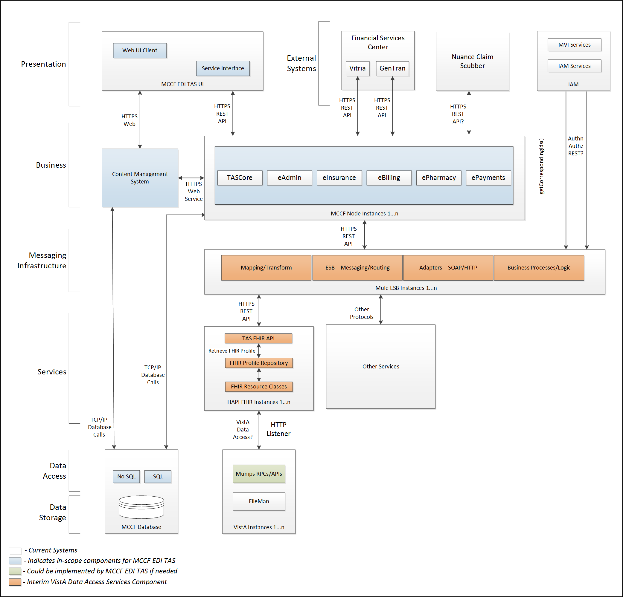

Figure - Interim Solution

To be solution

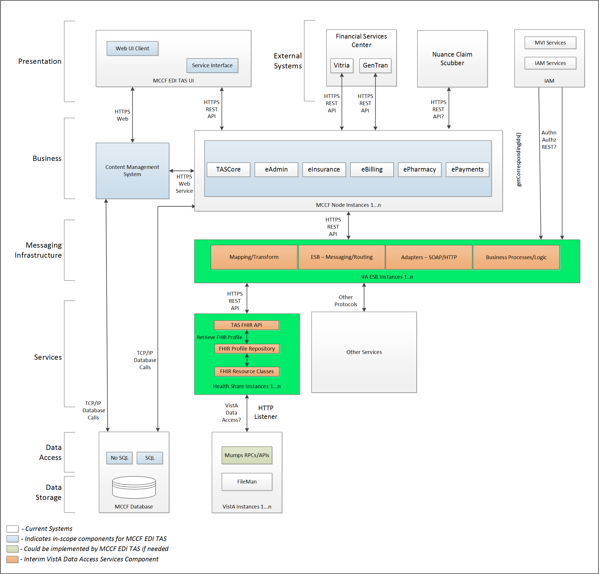

Figure - To Be Solution

## Interface Overview

Exchanging messages between MCCF EDI TAS eBilling and FSC can be done in real time or as queued messaging.

### Connectivity between the systems

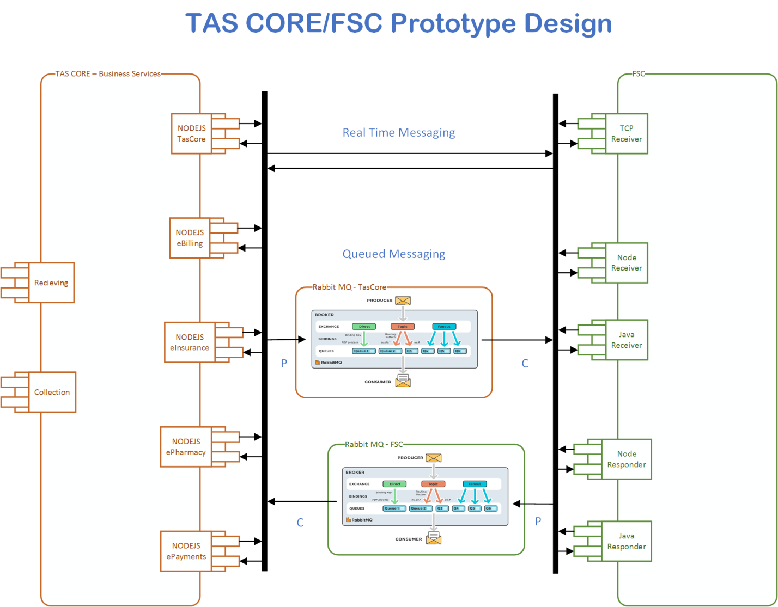

Figure - Connectivity

## Operations

Tbd

### Data Extraction

Data being sent to FSC will be extracted from the VistA databases using a FHIR server.

### Data Transformation

Tbd

### Sending/Receiving

MCCF EDI TAS sends FHIR Bundles to FSC that FSC translates to 278x217 request messages and receives FHIR Bundles representing 278x217 response messages from FSC.

MCCF EDI TAS sends FHIR Bundles to FSC that FSC translates to 278x215 inquiry messages and receives FHIR Bundles representing 278x215 responses from FSC.

## Data Transfer

Data is transferred between the FSC and the TASCore Application Stack.

## Transaction Types

MCCF EDI TAS transmits FHIR bundles consisting of the different FHIR resources needed to construct a 278x217 request and 278x215 inquiry type messages.

FSC receives 278x217 response and 278x215 response type messages from HCCH and transmits that data in FHIR resources inside FHIR bundles to MCCF EDI TAS.

## Data Exchanges

MCCF EDI TAS sends a 278 Request FHIR bundle (for 278x217 requests and 278x215 inquiries) to FSC and receives a 278 Response FHIR bundle (for 278x217 and 278x215 responses) from FSC. Refer to Section Appendix A.

### FHIR Based Resources

The following FHIR resources are needed to assemble a 278 Request FHIR bundle:

* Appointment
* Basic
* BodySite
* CarePlan
* ChargeItem
* Claim
* ClaimResponse
* ClinicalImpression
* Communication
* CommunicationRequest
* Condition
* Consent
* Coverage
* DataElement
* Device
* DiagnosticReport
* Encounter
* EpisodeOfCare
* HealthcareService
* Location
* MedicationAdministration
* MedicationDispense
* MedicationRequest
* MessageHeader
* Observation
* Organization
* Patient
* Practitioner
* PractitionerRole
* Procedure
* ProcessRequest
* RelatedPerson
* RiskAssessment
* ValueSet

The following FHIR resources are needed to assemble a 278 Response FHIR bundle:

* Basic
* BodySite
* CarePlan
* ChargeItem
* Claim
* ClaimResponse
* Communication
* CommunicationRequest
* Condition
* Coverage
* Device
* DiagnosticReport
* Encounter
* EpisodeOfCare
* HealthcareService
* Location
* MedicationAdministration
* MedicationDispense
* MessageHeader
* Observation
* OperationOutcome
* Organization
* Patient
* Practitioner
* PractitionerRole
* Procedure
* ProcessRequest
* RelatedPerson
* RiskAssessment

### JSON Format

Messages are formatted using the JSON format and implement a Bundle FHIR Resource.

Refer to <https://www.hl7.org/fhir/json.html> for JSON representation of FHIR Resources.

#### 278 Request FHIR bundle

A bundle implementing a 278 request sent to FSC will have the following structure:

See Appendix A section 3.3.1.

#### 278 Response FHIR bundle

A bundle implementing a 278 request sent to FSC will have the following structure:

See Appendix A section 3.3.2.

### Bundle Definition

A Bundle is a top-level container in FHIR that contains all the FHIR resources desired for a transaction between MCCF EDI TAS and FSC.

A Bundle is a container for resources, enabling one to group and transmit resources altogether at once. Resources such as Claim, Patient, etc. will be transmitted inside multiple entries (see entry list inside Bundle) as a resource type.

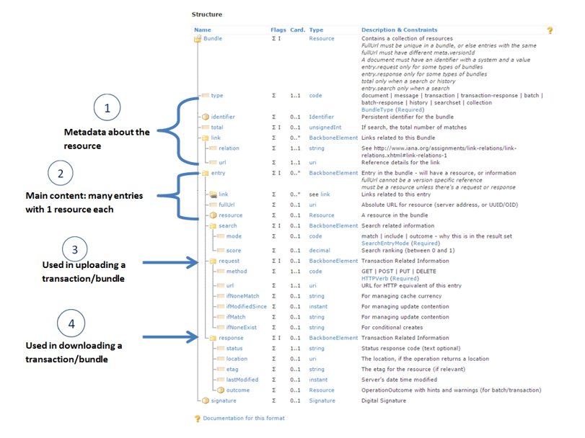

Figure – FHIR Bundle

Source https://fhir-drills.github.io/bundle.html

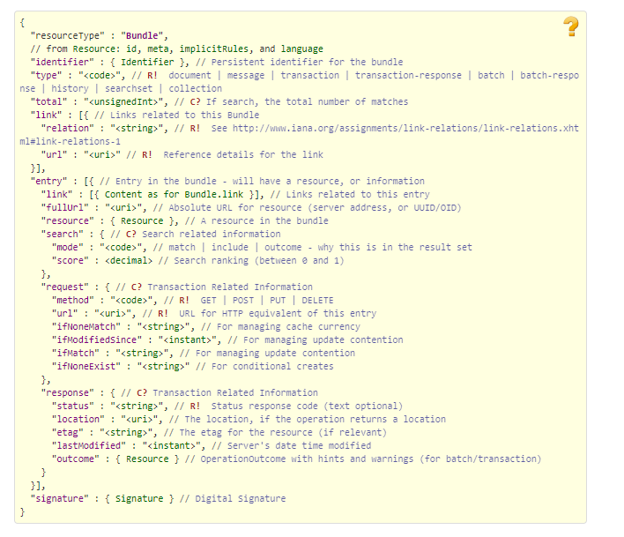

Figure – FHIR Bundle JSON

Source https://www.hl7.org/fhir/bundle.html

## Communications Methods

### Ports and Protocols

#### HTTP(S)

Can be used for real time communication.

#### Advanced Message Queuing Protocol (AMQP)

AMQP offers reliable messaging via queues.

### ESB Configuration(s)

tbd

### System Configuration

tbd

## Performance Requirements

Refer to MCCD EDI TAS SDD <https://vaww.oed.portal.va.gov/pm/hape/ipt_5010/EDI_Portfolio/TASCore/MCCF_EDI_TAS_System_Design_Document_v0.7.pdf>

## Security

Refer to MCCD EDI TAS SDD <https://vaww.oed.portal.va.gov/pm/hape/ipt_5010/EDI_Portfolio/TASCore/MCCF_EDI_TAS_System_Design_Document_v0.7.pdf>

## Testing Requirements

All the QA testing activities are defined in tasks tied to acceptance criteria in a user story. For each testing category there will be a unique user story. The testing categories are:

1. Connectivity/Secuirity
2. End to End
   1. There might be 2 different End to End test run at different times.
3. Regression testing/Error handling
4. Volume testing
   1. Performance testing
   2. Endurance testing
   3. Load testing
5. Smoke testing

### Comparison of Data

Testing the FHIR conformance will be based on <https://www.hl7.org/fhir/validation.html>.

Business Rules will have to be specifically defined in user stories by the product team (TAS).

* Which fields are mandatory from a business perspective?
* Data integrity.
  + There are different approaches that TASCore can employ to test data integrity, depending on future user stories and tasks that will define requirements:
    - Comparing the source data with the output data.
    - Parallel testing: Run data through existing data flow and through the new data flow and make sure data match.
    - Conformance testing (FHIR)
    - Data conformity to business specs
      * Date format
      * Decimal places
      * Currency notations
      * Etc.
* Error handling

### Completeness

Tests defined in section 2.10.1 must cover all the FHIR resources that are defined in section 2.6.1 in consideration of any functional user story.

### Load Testing

Bench mark tests must be performed based on individual use case requirements.

## Policies and Constraints

### HIPAA Compliance

FSC receives transactions and then translates them into standard ASC X12N/005010 278-217 Health Care Services Review – Request for Review and Response and ASC X12N/005010 278-215 Health Care Services Review – Inquiry and Response, validates whether the data complies with HIPAA standards and then forwards the claim data to the VA Healthcare Clearing House (HCCH).

# Appendix A

## Data Elements

Data being exchanged between TAS and FSC will be formatted in FHIR using the JSON notation. Data elements are mapped into fields in FHIR resources. FHIR resources will be located inside a FHIR bundle.

MessageHeader.event.code in Bundle entry Bundle.entry.extension.url="segment", Bundle.entry.extension.valueString="278-EVN" will be used to differentiate between a 278-217 and a 278-215 request/response. For 278-217 the value in this field will be “13” and for 278-215 the value in this field will be “28”.

## Bundle

Repeating fields within a segment need context definition so they can be differentiated within a segment.

Also, repeating fields across multiple segments need to be differentiated. Following steps have been used to assign context to fields.

1. Identify the segment where the resource is located (Bundle.entry.extension.url="segment" and Bundle.entry.extension.valueString="278-EVN") [MessageType-Segment]

2. Where elements repeat within a segment use extension.valueString to identify field (Basic.extension.url="sequence" and Basic.extension.valueString="278-MSH-16" or Location.identifier.extension.url="sequence" and Location.identifier.extension.valueString="278-MSH-3") [MessageType-Segment-Field]

3. Repeating segments will include an incrementing id (MSA1, MSA2, ...)

Following JSON files describe the 278 request and response bundles.



## Resource Sections

### 278 Request FHIR Bundle Resources

#### Appointment

See Appointment resource in Bundle included in section 3.2

#### Basic

See Basic resource in Bundle included in section 3.2

#### BodySite

See BodySite resource in Bundle included in section 3.2

#### CarePlan

See CarePlan resource in Bundle included in section 3.2

#### ChargeItem

See ChargeItem resource in Bundle included in section 3.2

#### Claim

See Claim resource in Bundle included in section 3.2

#### ClaimResponse

See ClaimResponse resource in Bundle included in section 3.2

#### ClinicalImpression

See ClinicalImpression resource in Bundle included in section 3.2

#### Communication

See Communication resource in Bundle included in section 3.2

#### CommunicationRequest

See CommunicationRequest resource in Bundle included in section 3.2

#### Condition

See Condition resource in Bundle included in section 3.2

#### Consent

See Consent resource in Bundle included in section 3.2

#### Coverage

See Coverage resource in Bundle included in section 3.2

#### DataElement

See DataElement resource in Bundle included in section 3.2

#### Device

See Device resource in Bundle included in section 3.2

#### DiagnosticReport

See DiagnosticReport resource in Bundle included in section 3.2

#### Encounter

See Encounter resource in Bundle included in section 3.2

#### EpisodeOfCare

See EpisodeOfCare resource in Bundle included in section 3.2

#### HealthcareService

See HealthcareService resource in Bundle included in section 3.2

#### Location

See Location resource in Bundle included in section 3.2

#### MedicationAdministration

See MedicationAdministration resource in Bundle included in section 3.2

#### MedicationDispense

See MedicationDispense resource in Bundle included in section 3.2

#### MedicationRequest

See MedicationRequest resource in Bundle included in section 3.2

#### MessageHeader

See MessageHeader resource in Bundle included in section 3.2

#### Observation

See Observation resource in Bundle included in section 3.2

#### Organization

See Organization resource in Bundle included in section 3.2

#### Patient

See Patient resource in Bundle included in section 3.2

#### Practitioner

See Practitioner resource in Bundle included in section 3.2

#### PractitionerRole

See PractitionerRole resource in Bundle included in section 3.2

#### Procedure

See Procedure resource in Bundle included in section 3.2

#### ProcessRequest

See ProcessRequest resource in Bundle included in section 3.2

#### RelatedPerson

See RelatedPerson resource in Bundle included in section 3.2

#### RiskAssessment

See RiskAssessment resource in Bundle included in section 3.2

#### ValueSet

See ValueSet resource in Bundle included in section 3.2

### 278 Response FHIR Bundle Resources

#### Basic

See 278 Response FHIR Bundle Resources Basic resource in section 3.2

#### BodySite

See 278 Response FHIR Bundle Resources BodySite resource in section 3.2

#### CarePlan

See 278 Response FHIR Bundle Resources CarePlan resource in section 3.2

#### ChargeItem

See 278 Response FHIR Bundle Resources ChargeItem resource in section 3.2

#### Claim

See 278 Response FHIR Bundle Resources Claim resource in section 3.2

#### ClaimResponse

See 278 Response FHIR Bundle Resources ClaimResponse resource in section 3.2

#### Communication

See 278 Response FHIR Bundle Resources Communication resource in section 3.2

#### CommunicationRequest

See 278 Response FHIR Bundle Resources CommunicationRequest resource in section 3.2

#### Condition

See 278 Response FHIR Bundle Resources Condition resource in section 3.2

#### Coverage

See 278 Response FHIR Bundle Resources Coverage resource in section 3.2

#### Device

See 278 Response FHIR Bundle Resources Device resource in section 3.2

#### DiagnosticReport

See 278 Response FHIR Bundle Resources DiagnosticReport resource in section 3.2

#### Encounter

See 278 Response FHIR Bundle Resources Encounter resource in section 3.2

#### EpisodeOfCare

See 278 Response FHIR Bundle Resources EpisodeOfCare resource in section 3.2

#### HealthcareService

See 278 Response FHIR Bundle Resources HealthcareService resource in section 3.2

#### Location

See 278 Response FHIR Bundle Resources Location resource in section 3.2

#### MedicationAdministration

See 278 Response FHIR Bundle Resources MedicationAdministration resource in section 3.2

#### MedicationDispense

See 278 Response FHIR Bundle Resources MedicationDispense resource in section 3.2

#### MessageHeader

See 278 Response FHIR Bundle Resources MessageHeader resource in section 3.2

#### Observation

See 278 Response FHIR Bundle Resources Observation resource in section 3.2

#### OperationOutcome

See 278 Response FHIR Bundle Resources OperationOutcome resource in section 3.2

#### Organization

See 278 Response FHIR Bundle Resources Organization resource in section 3.2

#### Patient

See 278 Response FHIR Bundle Resources Patient resource in section 3.2

#### Practitioner

See 278 Response FHIR Bundle Resources Practitioner resource in section 3.2

#### PractitionerRole

See 278 Response FHIR Bundle Resources PractitionerRole resource in section 3.2

#### Procedure

See 278 Response FHIR Bundle Resources Procedure resource in section 3.2

#### ProcessRequest

See 278 Response FHIR Bundle Resources ProcessRequest resource in section 3.2

#### RelatedPerson

See 278 Response FHIR Bundle Resources RelatedPerson resource in section 3.2

#### RiskAssessment

See 278 Response FHIR Bundle Resources RiskAssessment resource in section 3.2

### Mapping Sheet



Refer to the following attachment to see which fields apply to 278-215 and which apply to 278-217:



# Appendix B - TASCore Mapping Rules

Tbd

# Appendix C – TASCore Default Values

Tbd

# Appendix D – FSC Mapping Rules

Tbd

# Appendix E – FSC Default Values

See mapping sheet section 3.3.3

# Appendix F – Glossary

| **Term** | **Meaning** |
| --- | --- |
| AMQP - Advanced Message Queuing Protocol | The *Advanced Message Queuing Protocol* (*AMQP*) is an open standard for passing business messages between applications or organizations using queues. |
| HCCH | Health Care Clearing House |
| REST - REpresentational State Transfer | REpresentational State Transfer, or RESTful web services provide interoperability between computer systems on the Internet or other network. Sometimes spelled ReST. |

# Attachment A – Approval Signatures

This section is used to document the approval of the ICD. The review should be conducted face to face where signatures can be obtained ‘live’ during the review. If unable to conduct a face-to-face meeting then it should be held via Lync and concurrence captured during the meeting. The Scribe should add /es/name by each position cited.

By signing below, I agree that I have reviewed and agree the document is approved.

